Dear Patients of The Wellbridge Practice,
Following on from the statement released on 12th May on our Facebook page by our PCN (Primary Care Network) Clinical Director Dr David Haines we wanted to update you on a more personal level.
Along with every GP practice in the country we are in crisis. In 2018 Dorset had 470 GPs, that figure is now down by 15% to 399!* The workload that is endured is unsustainable, unhealthy, and unsafe. The demand for appointments is at an all-time high and we are seeing more patients than ever before. We often hear comments that we should work full time so we can see more patients, but the truth is we do work full-time. Consultations are just one aspect of our roles. We also have hundreds of letters, results, and paperwork to look at and action daily which now encroaches into our ‘non-working’ days just to keep on top of things.
Like all areas of the NHS staffing is a problem. We have seen a staff turnaround like never before due to the ongoing pressures. We now have 4 Doctors having recently lost one of our salaried Doctors associated with constant pressures. We have been trying to recruit for a very long time with no success. What you are seeing in the media is true, there are less GPs now than there has ever been, but more patients want appointments. Many, many surgeries are facing the same problems and have started to close and further surgeries will be at risk of closure.
As a team we are fully committed to you all and want to be able to keep providing a service as good as possible to our community, but we need your help to be able to do this. We cannot continue at the rate we are currently working. Our dedicated team cannot continue to sustain the level of disrespect that they have been receiving. We understand your frustrations at not being able to get an appointment when you want it, but we are working far beyond capacity and seeing more patients than ever before. We cannot just simply add more appointments, we have to work under nationally recommended levels, we are human too. We very often hear comments made to our receptionists that ‘it’ll only take a minute’ or ‘I just need a quick chat’ please understand it would be impossible to maintain that kind of service for our patient population.
So how can you help us?
Self-care – most illnesses get better on their own over time. Please only contact us if symptoms persist. You can find lots of information on Get help for your symptoms - NHS 111, or our website www.wellbridge.co.uk.
Go to a Pharmacist – there are many ailments that a pharmacist can deal with like cough, colds, sore throat, earache, sinusitis, conjunctivitis, hay fever, constipation, diarrhoea, cystitis, rashes, general pain, and medication queries. Please make community pharmacists your first port of call and they will advise you and will also refer you to a GP if necessary.
See other allied health professionals – First contact Physio, in house pharmacist.
Minor Injury Units- you can access MIU by ringing 111 for cuts, grazes, sprains, and breaks.
Self-refer – to STW for depression, anxiety, and stress Steps 2 Wellbeing. You can also self-refer to physiotherapy for back & joint pain Looking after yourself | Musculoskeletal Matters (mskdorset.nhs.uk).
Working as part of Purbeck PCN we work together with 5 other surgeries within Purbeck, and we are constantly trying to recruit more staff and offer more services. We already have a First contact Physiotherapist and a team of pharmacists and pharmacy technicians, but appointments are limited as they work across all 6 surgeries, but please accept these if offered.
Last month we had 63 appointments that were DNA’d (Did Not Attend) which equates to approx. two days of surgery for a GP! If you are successful in securing an appointment, please make sure you attend or cancel it if circumstances change. DNA’d appointments continue to exacerbate availability issues.
If you have any suggestions on how we can improve things, please do let us know. We are always happy to hear your ideas but please bear in mind the problems cannot be solved by employing more staff as the staff are just not there to employ.
Our plea to you is please use us wisely so we can be there for those that truly need us and please be kind to all of our team. They are the most committed and loyal team and without them there would not be a Wellbridge Practice.
Thank you
Dr French, Dr Mugford & Dr Dennison.

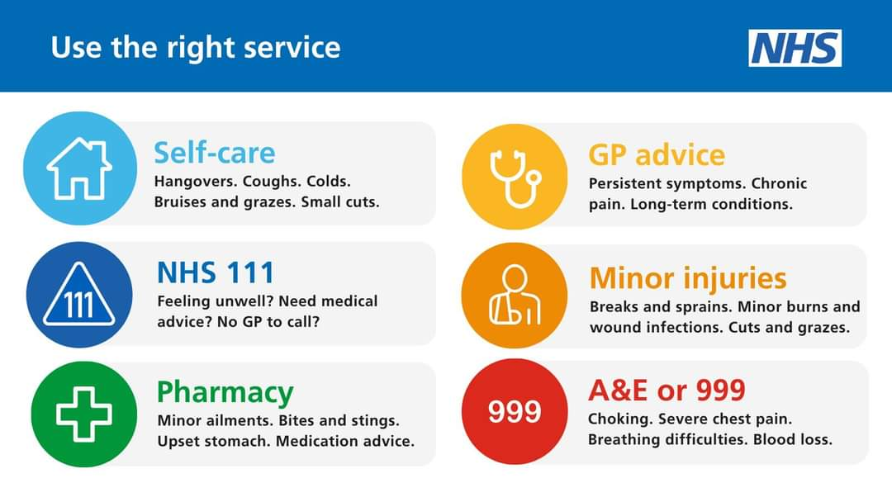
*figures taken from Sept 22

